Deutschland, 1933-1990
Wählen- SS-
die Wahl- einfallen-
die Partei- verstecken-
der Krieg- schmuggeln-
die Regierung- der Lebensraum-
das Reich- der Führer-
der Jude- leiten/führen -
jüdisch-
das Konzentrationslager-
die Reich-Kristallnacht-
die Grenze-
der Ausweis-
die BRD- Bundes Republik Deutschland
die DDR- Deutsche Demokratische Republik
Checkpoint Charlie-
die Weisse Rose-
die Welle-
das Hakenkreuz- Nazi-
How Hitler got to the top of the Government & became Chancellor
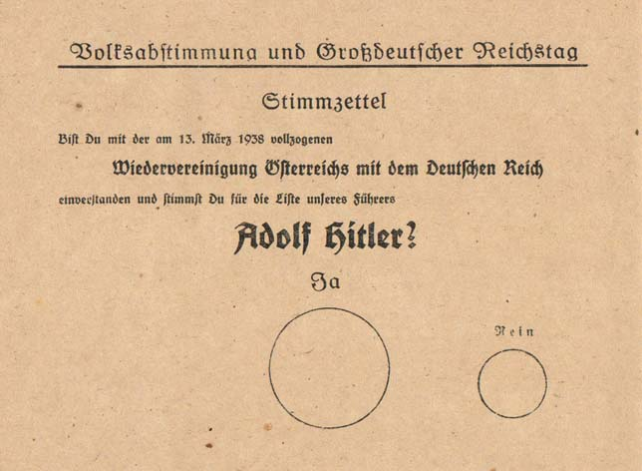
MAIN VOTING BALLOT FOR CHANCELLOR AND REUNION WITH AUSTRIA
- Total manipulation (big yes, already made decisions, two things at the same time) Voting was just formal decision was already made
- Bundestag (“white house” from Germany) was set on fire, Hitler said that he needs to protect the German people and the President gave his signature for a law, which completely limited the basic rights from people and the government Hitler and NSDAP got unlimited power over People and Gov.
- Voting for two things at the same time (Reunion with Austria & Hitler as chancellor)
- Every person wanted the reunion with Germany and Austria
- 99,1% of the people voted for yes
- Non valid voting’s and not given votes were automatically a yes (rest of 0.9%)
- Only opportunity was NSDAP because of “Notverordnung”
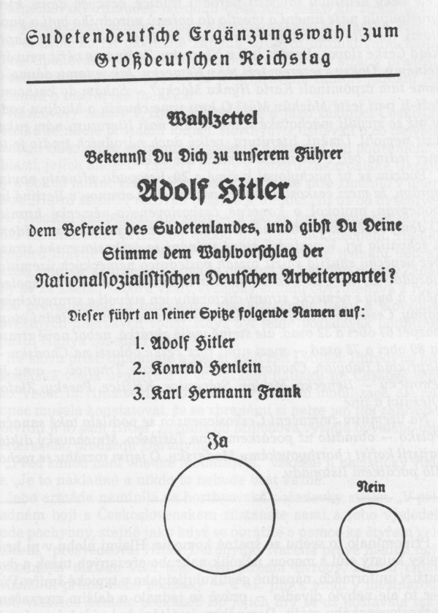
SECOND BALLOT, ONLY HITLER AND HIS PEOPLE
“Ergänzungswahl - Additional Voting”

